Mongo DB :

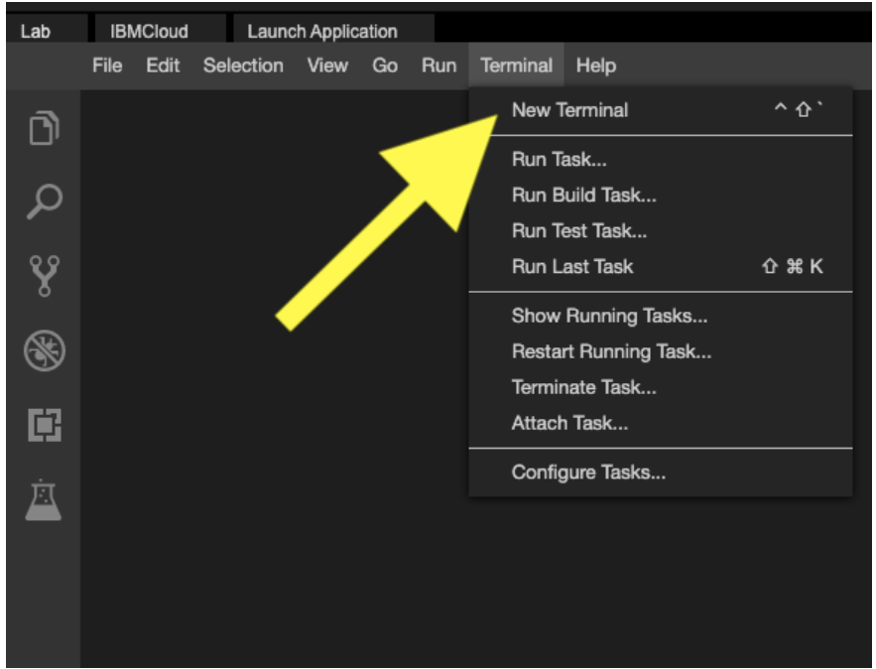

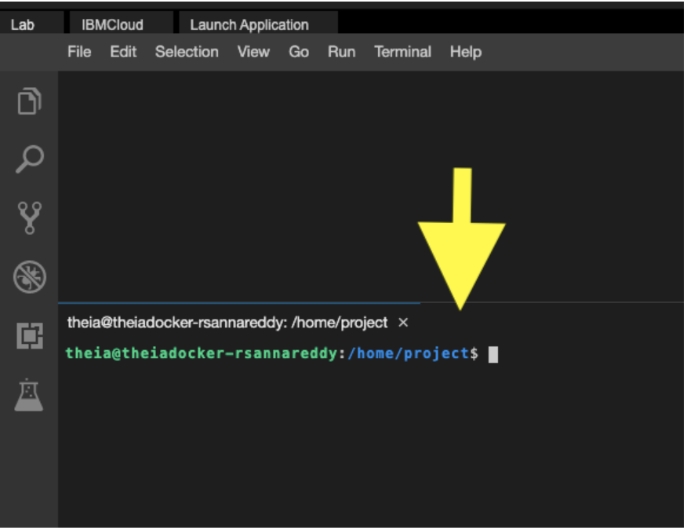

start_mongo

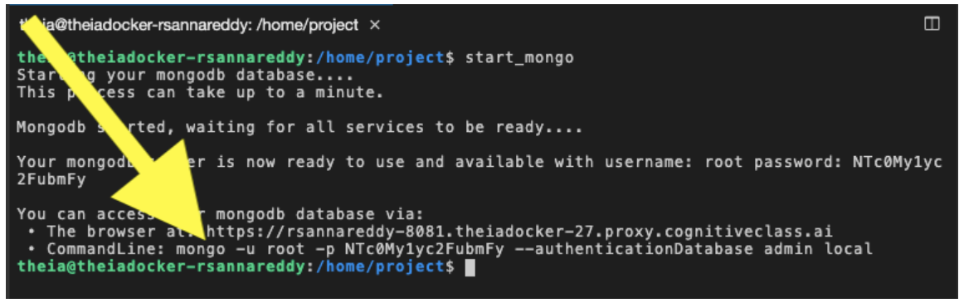

mongo -u root -p NTc0My1yc2FubmFy --authenticationDatabase admin local

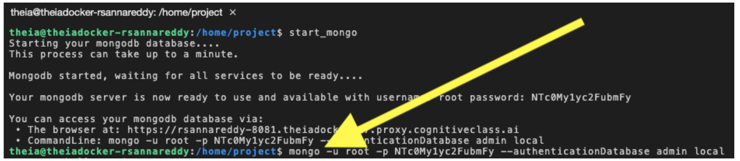

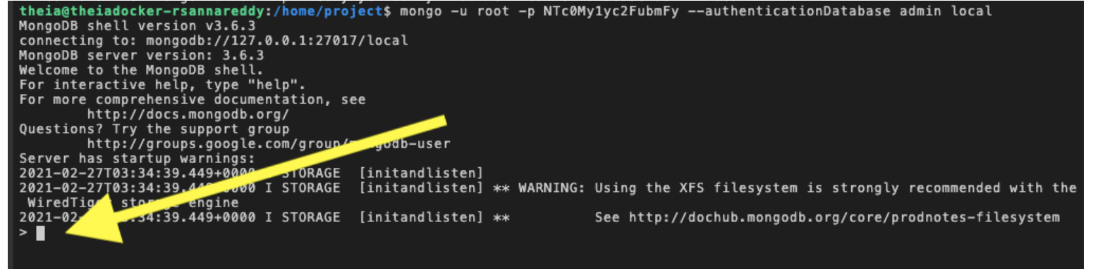

**Exercise 3 - Find the version of the server**

On the mongo client run the below command.

db.version()

This will show the version of the mongodb server.

**Exercise 4 - List databases**

On the mongo client run the below command.

show dbs

This will print a list of the databases present on the server.

**Exercise 5 - Create database**

On the mongo client run the below command.

use training

This will create a new database named **training**. If a database named training already exists, it will start using it.

**Exercise 6 - Create collecton**

On the mongo client run the below command.

db.createCollection("mycollection")

This will create a collection name **mycollection** inside the **training** database.

**Exercise 7 - List collections**

On the mongo client run the below command.

show collections

This will print the list of collections in your current database.

**Exercise 8 - Insert documents into a collection**

On the mongo client run the below command.

db.mycollection.insert({"color":"white","example":"milk"})

The above command inserts the json document {"color":"white","example":"milk"} into the collection.

Let us insert one more document.

db.mycollection.insert({"color":"blue","example":"sky"})

The above command inserts the json document {"color":"blue","example":"sky"} into the collection.

Insert 3 more documents of your choice.

**Exercise 9 - Count the number of documents in a collection**

On the mongo client run the below command.

db.mycollection.count()

This command gives you the number of documents in the collection.

**Exercise 10 - List all documents in a collection**

On the mongo client run the below command.

db.mycollection.find()

This command lists all the documents in the collection **mycollection**

Notice that mongodb automatically adds an '_id' field to every document in order to uniquely identify the document.

**Exercise 11 - Disconnect from mongodb server**

On the mongo client run the below command.

exit